***Project Report Template***

**IMPLEMENTING CRM FOR RESULT TRACKNG OF A CANDIDATE WITH INTERNAL MARKS**

***1.Introduction***

***1.1 Overview***

Our project is to create a CRM for tracking the results of the candidates with their internal marks. This CRM helpful to find the internal marks of the candidates

***1.2 Purpose***

This project used to find the internal marks of the candidates. This CRM was more useful to schools and colleges to find a student/candidate of their internal marks. It also used for in some company to find the candidates with highest marks, so this CRM plays significant role in our society

***2. Problem Definition & Design Thinking***

***2.1 Empathy Map*** 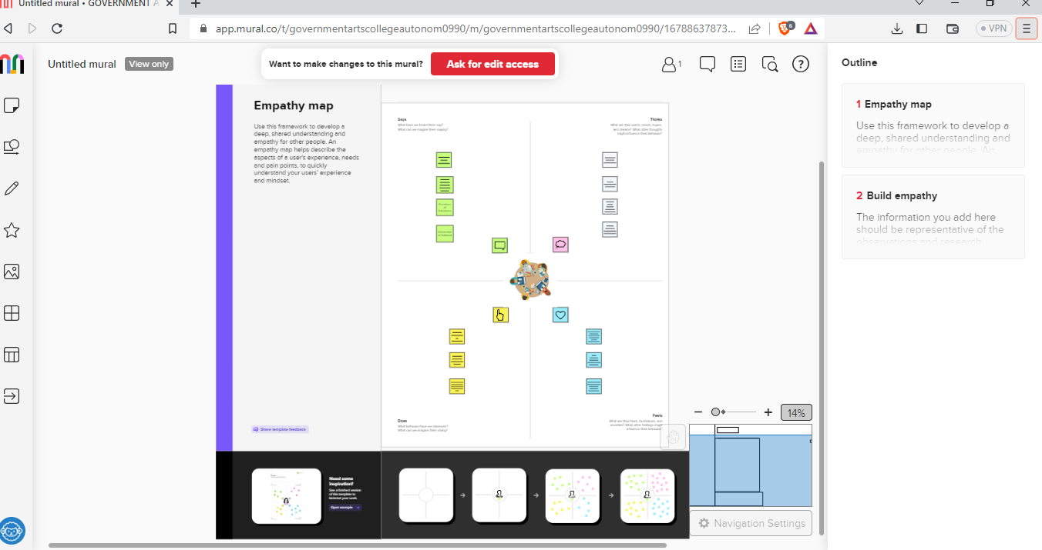

***2.2 Ideation & Brainstorm Map***

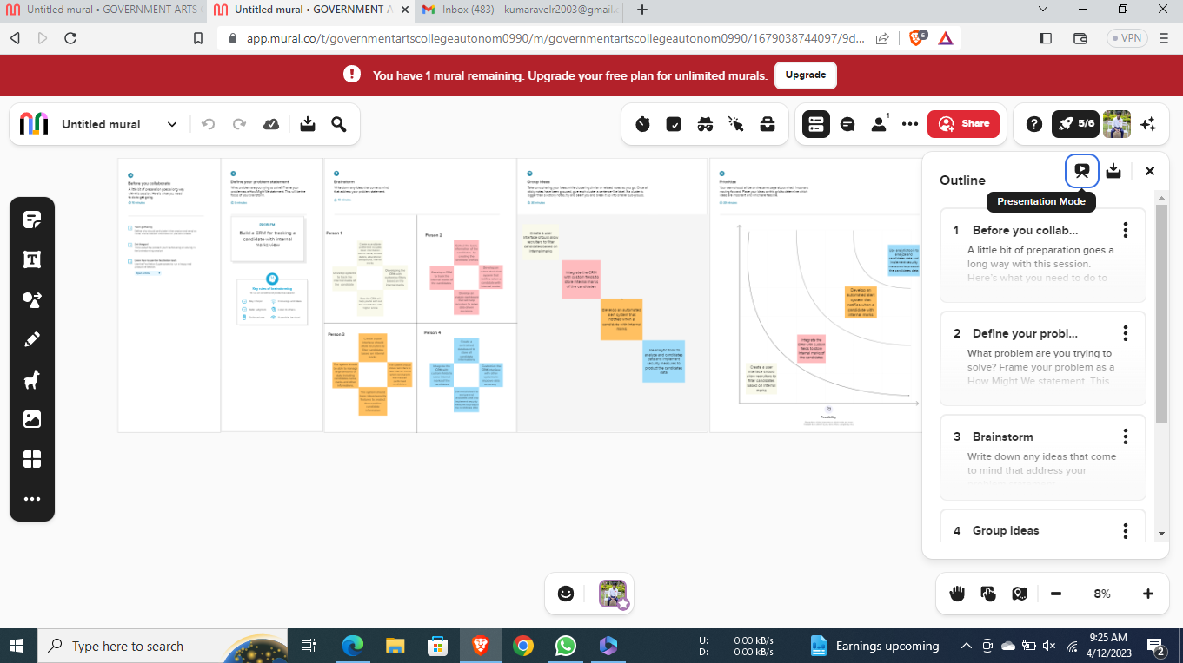

***3 Result***

***3.1 Data Model***

|  |  |
| --- | --- |
| *Object name* | *Fields in the object* |
| *Object 1* | |  |  | | --- | --- | | *Field label* | *Data type* | | *Semester* | *Text* | |
| *Object 2* | |  |  | | --- | --- | | *Field label* | *Data type* | | *Candidate Name* | *Text* | | *Candidate Id* | *Text* | | *Semester Name* | *Text* | |
| *Object 3* | |  |  | | --- | --- | | *Field label* | *Data type* | | *Course Name* | *Text* | | *Course Id* | *Text* | |
| *Object 4* | |  |  | | --- | --- | | *Field label* | *Data type* | | *Lecturer Role* | *Text* | | *Lecturer Name* | *Text* | | *Course Id* | *Text* | |
| *Object 5* | |  |  | | --- | --- | | *Field label* | *Data type* | | *Candidate Id* | *Text* | | *Course Id* | *Text* | | *Marks* | *Text* | |

***3.2 Activity and Screenshot***

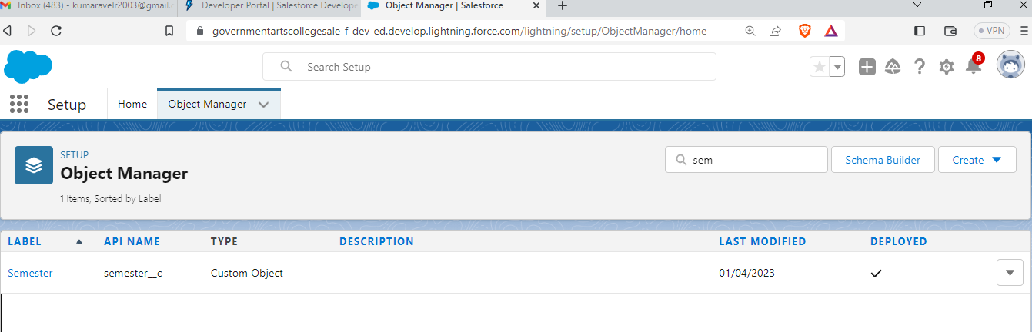

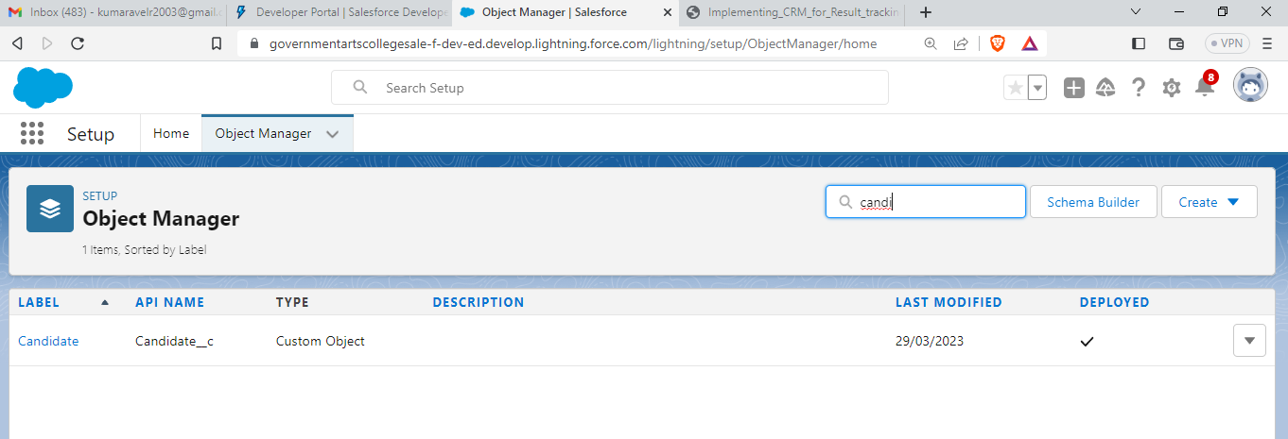

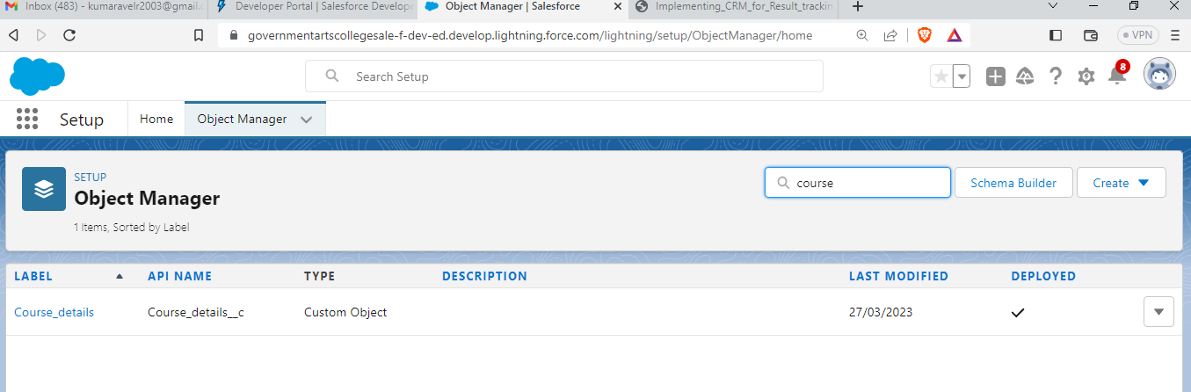

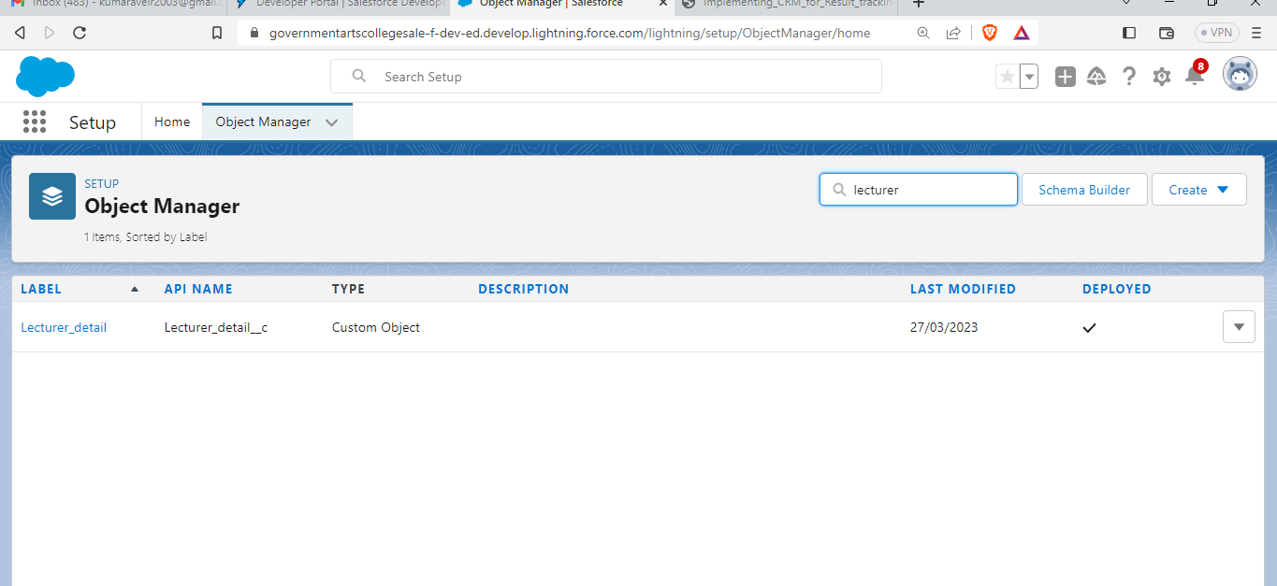

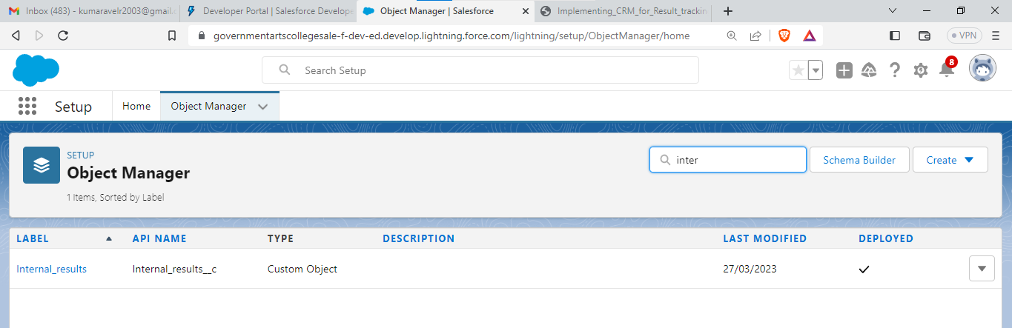

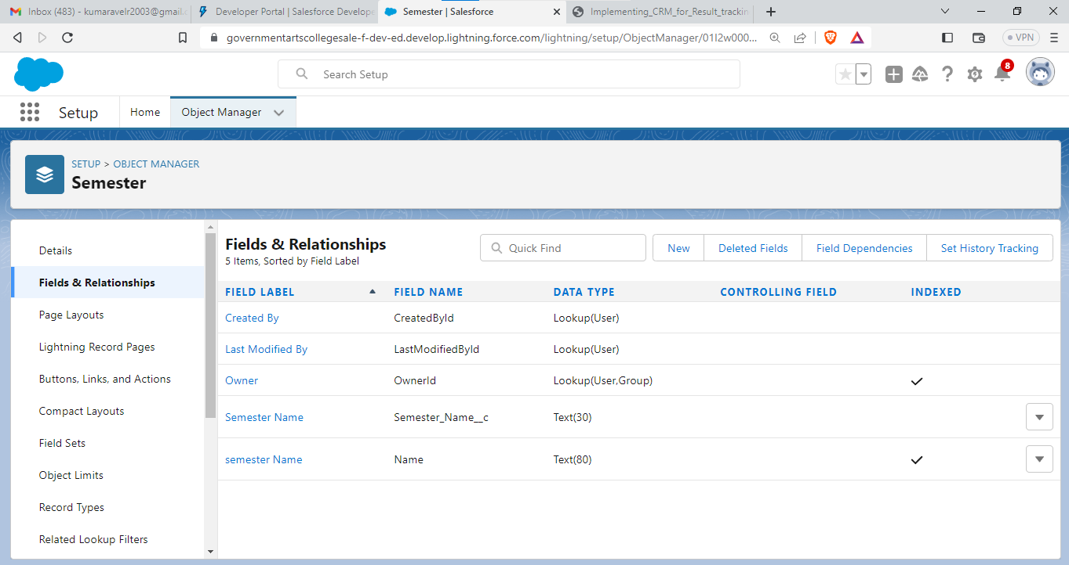

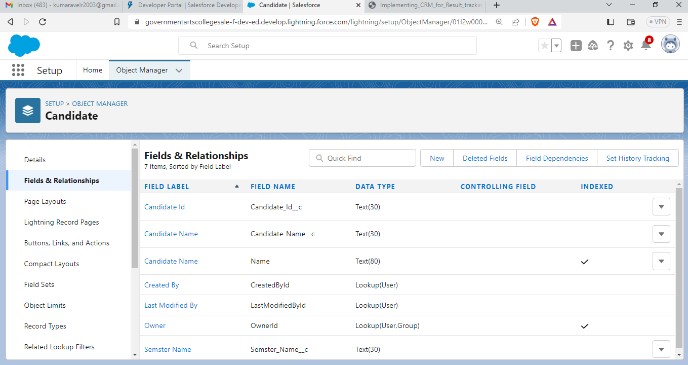

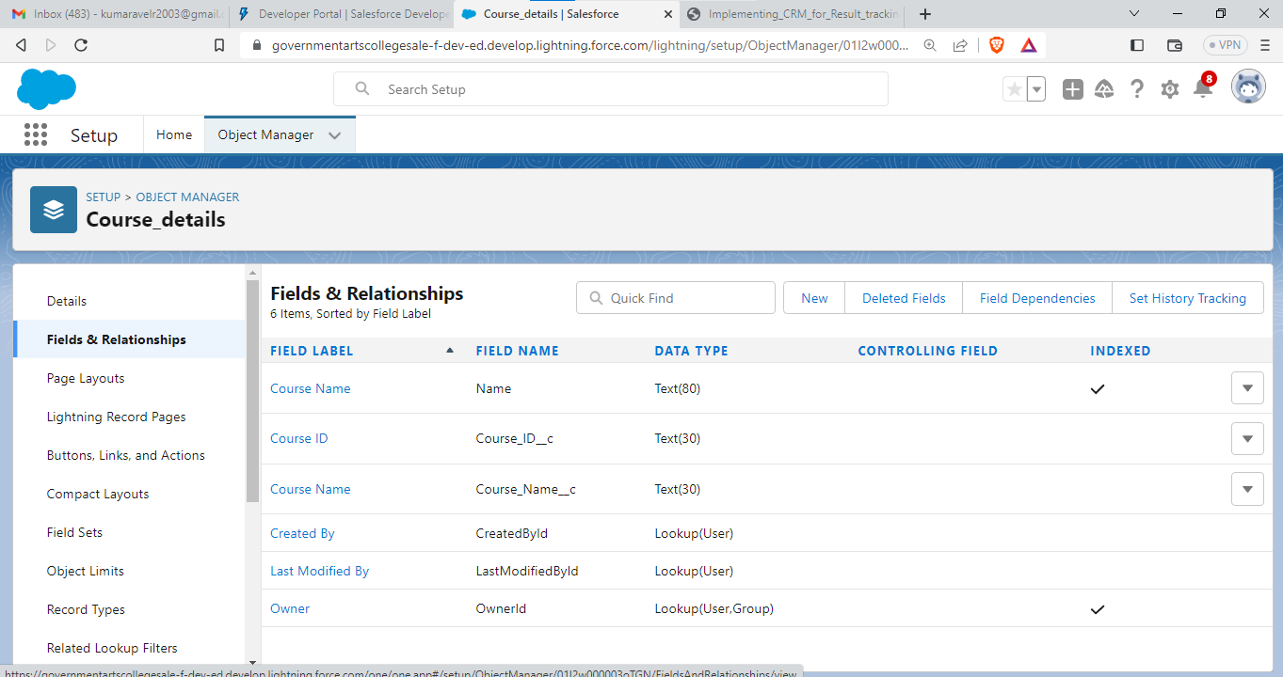

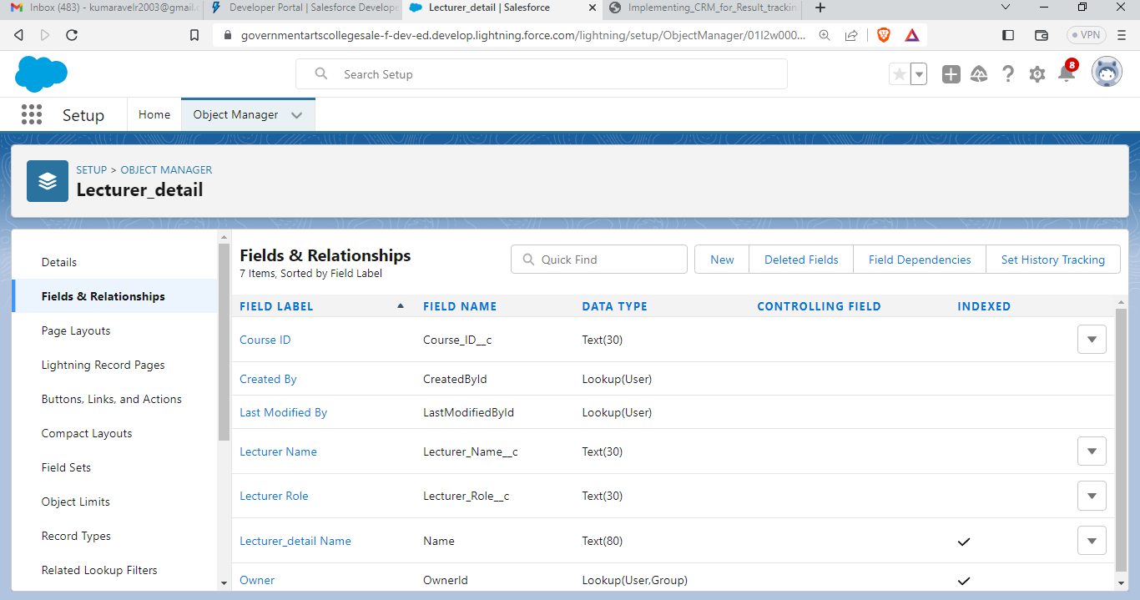

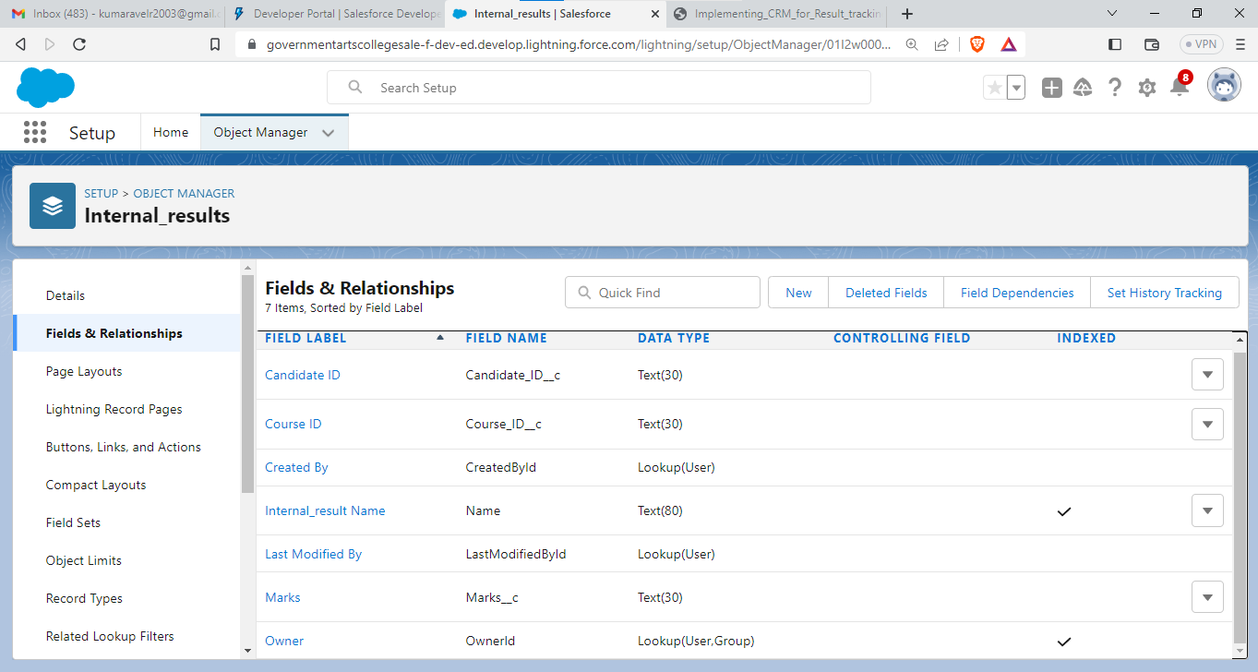

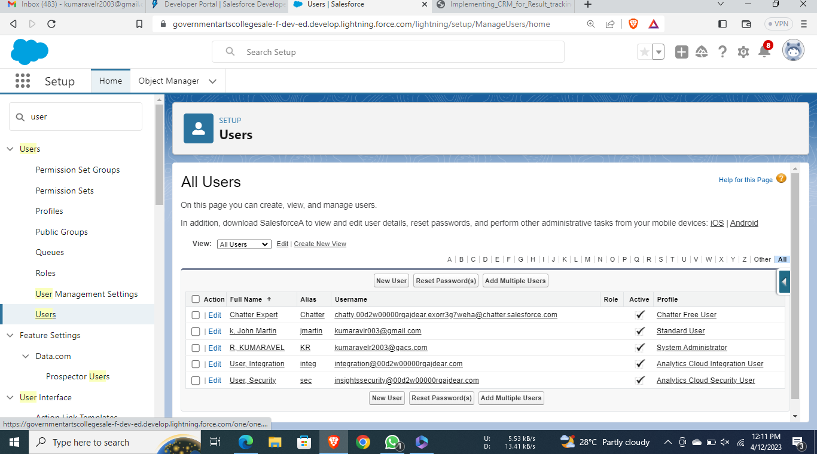

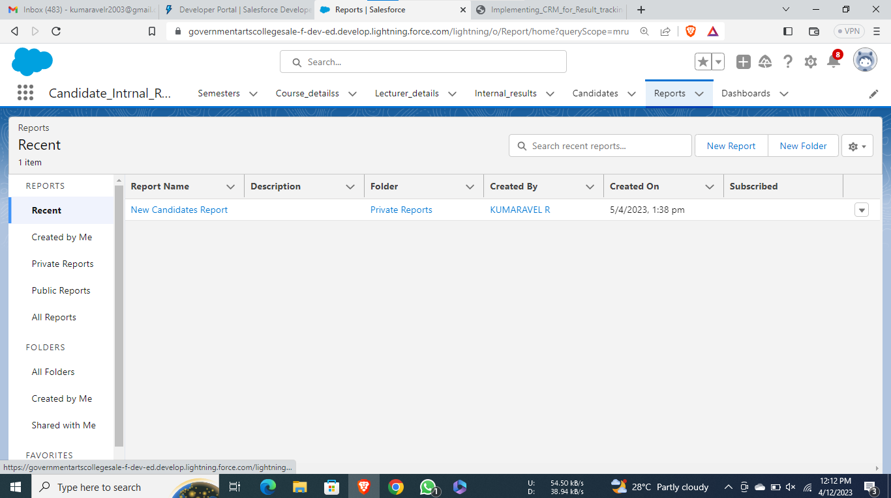

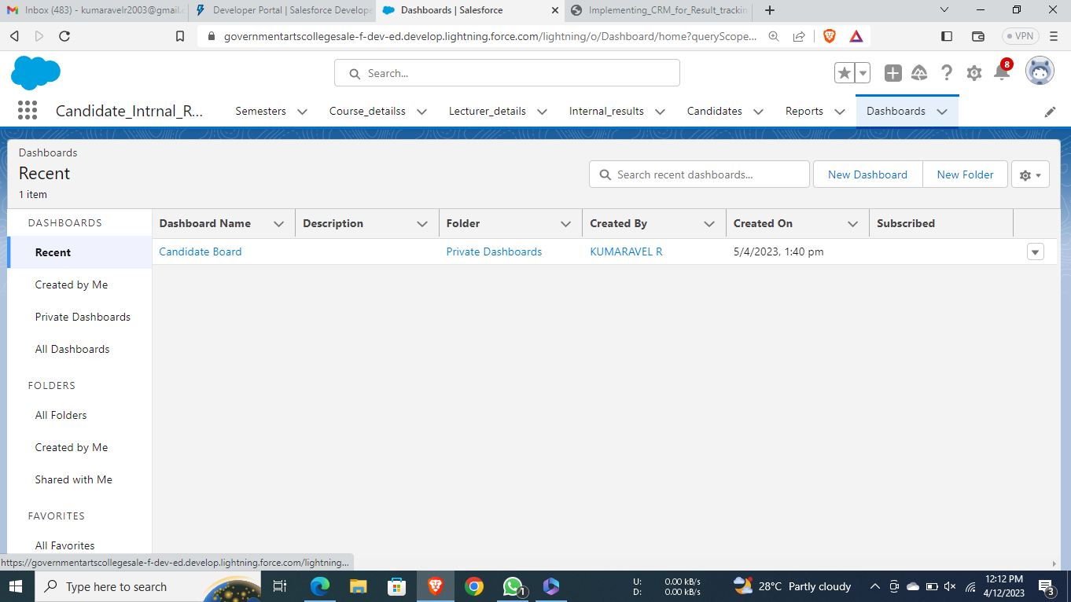

***4 Trailhead Profile Public URL***

Team Lead- https://trailblazer.me/id/kishb4

Team Member 1- https://trailblazer.me/id/krajendran41

Team Member 2-https://trailblazer.me/id/keerk48

Team Member 3- https://trailblazer.me/id/keerk49

***5 Advantages***

Improved candidate tracking: A CRM system can help recruiters track candidates throughout the hiring process, from the initial application stage to the final interview. This can help recruiters keep track of candidates' internal marks, which can be an important factor in the hiring decision.

Increased efficiency: By using a CRM system, recruiters can automate many of the repetitive tasks involved in the hiring process, such as sending emails to candidates or scheduling interviews. This can save time and increase the efficiency of the hiring process.

Better communication: A CRM system can provide a centralized platform for communication between recruiters and candidates. This can help ensure that candidates are kept up to date on the status of their application and can also help recruiters communicate more effectively with each other.

Improved data management: A CRM system can help recruiters manage candidate data more effectively, ensuring that all relevant information is stored in one place. This can help prevent data loss and ensure that all recruiters have access to the same information.

***Disadvantages:***

Cost: Implementing a CRM system can be expensive, especially for smaller organizations. This may make it difficult for some organizations to justify the cost of implementing such a system.

Training: Using a CRM system may require training for recruiters who are not familiar with the technology. This can be time-consuming and may require additional resources.

Integration: Integrating a CRM system with existing software can be challenging, especially if the organization is using multiple software systems. This may require additional IT resources and expertise.

Security: A CRM system may contain sensitive candidate data, such as internal marks. Ensuring the security of this data can be a significant challenge, especially if the organization does not have robust IT security measures in place.

***Applications:***

Implementing Customer Relationship Management (CRM) software for tracking candidates with internal marks can be very useful in several ways. Here are some potential usages:

Streamline Candidate Management: With a CRM system in place, you can easily track and manage candidates based on their internal marks. This can help you keep track of their progress through the recruitment process, which stages they have passed, and where they are in the hiring funnel. This can be especially useful if you have a large number of candidates to manage.

Improve Candidate Engagement: A CRM system can help you maintain a personalized relationship with candidates throughout the recruitment process. By tracking their internal marks, you can get a better sense of their strengths and weaknesses and tailor your communication to their specific needs. This can help improve candidate engagement and increase the chances of them accepting a job offer.

Analyze Recruitment Performance: A CRM system can provide valuable insights into your recruitment performance. By tracking the internal marks of candidates, you can analyze which recruitment sources are producing the most successful candidates and identify areas for improvement in your recruitment process.

***Conclusion***

while implementing a CRM system for tracking candidates with internal marks can offer many benefits, organizations must also consider the potential disadvantages and ensure that they have the resources and expertise to implement and maintain such a system effectively.

***Future scope:***

Enhanced Candidate Experience: A CRM system can be leveraged to personalize the candidate experience, providing a seamless and engaging experience to the candidates. It can also help in managing communication with the candidates, providing regular updates on the status of their application, interview schedule, and feedback.

Better Recruitment Analytics: A CRM system can provide valuable insights into the recruitment process, allowing HR professionals to track and analyze candidate data. It can help in identifying recruitment trends, tracking the effectiveness of recruitment channels, and identifying areas for improvement.